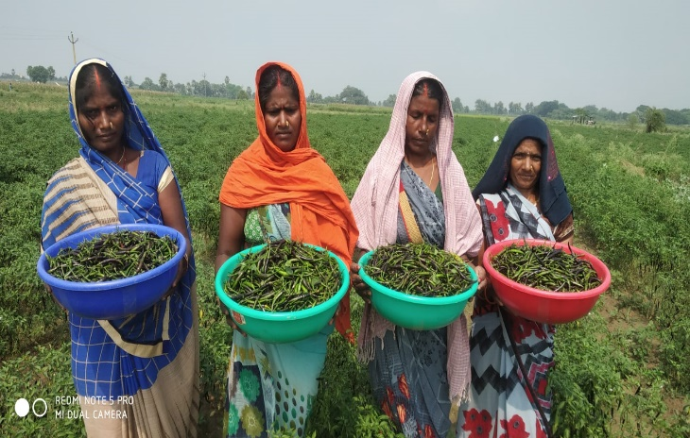

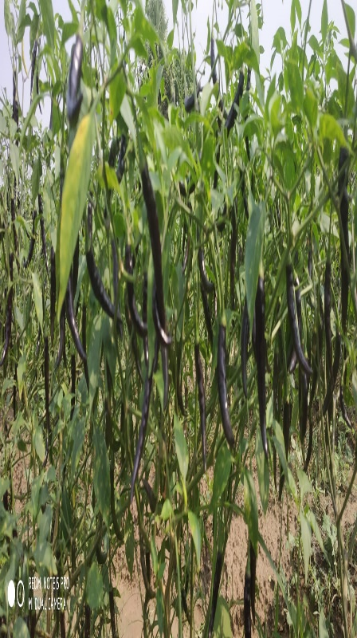

**Farmer Name – Mr. Sarwar Siddiqui**

**No of Plant – 6938**

**DOS-20-6-2021**

**DOT-28-7-2021**

**Variety – Krishna**

**Location – village- Pakhanpura,**

**Thana – Bhawarkoal Tehsil – Muhammdabad**

**Piking Details -:**

|  |  |  |  |
| --- | --- | --- | --- |
| **Picking** | **Date** | **Quantity** | **Rate in Mandi** |
| 1st Picking | 21/09/2021 | 11.4 kg | ₨ 29/kg |
| 2nd Picking | 05/10/2021 | 217.9 kg | Rs 33/kg |
| 3rd Picking | 16/10/2021 | 749 Kg | Rs 31.5/kg |
| 4th Picking | 11/11/2021 | 1572Kg | Rs 33.5/kg |
| 5th Picking | 23/12/2021 | 2700 Kg | Rs 23/KG |
|  | |  |  |