**OFD REPORT OF 1-14**

Name of the farmer : Kamalkanta Singh

S/O : Laxmidhar Singh

Village : Jagamainshigotha

PO : Gopidashipur

Dist : Bhadrak

State : Odisha

Mob no : 8018761208

Land : 0.12 Acres

Demo : 1-14(VNR)

Trial : Arjun(EW)

DOS : 15/10/17

First harvest :16/12/17

Harvest Quantity : 100kg approx

Average Size : 8-10 Kg

Report Details:-

Plants tolerant to YVMV and DM. Good creeper. Vigorous fruiting as compare to Arjun. 15 days early fruiting as compare to Arjun. One plant bears 5 to 6 fruits of uniform size of 8 to 10 kg where as Arjun bears 2 to 3 fruits of 2 to 3 kg size.

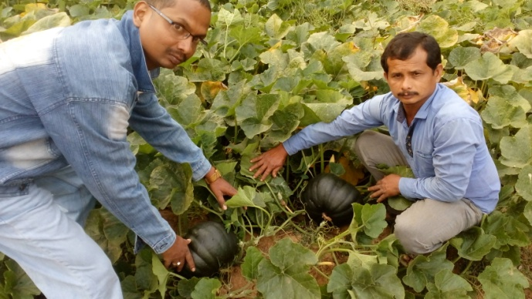

VNR 1-14

Internal pulp is yellowish in color and pulp thickness is good. Taste is so sweet .

**(INTERNAL PICTURE OF 1-14)**

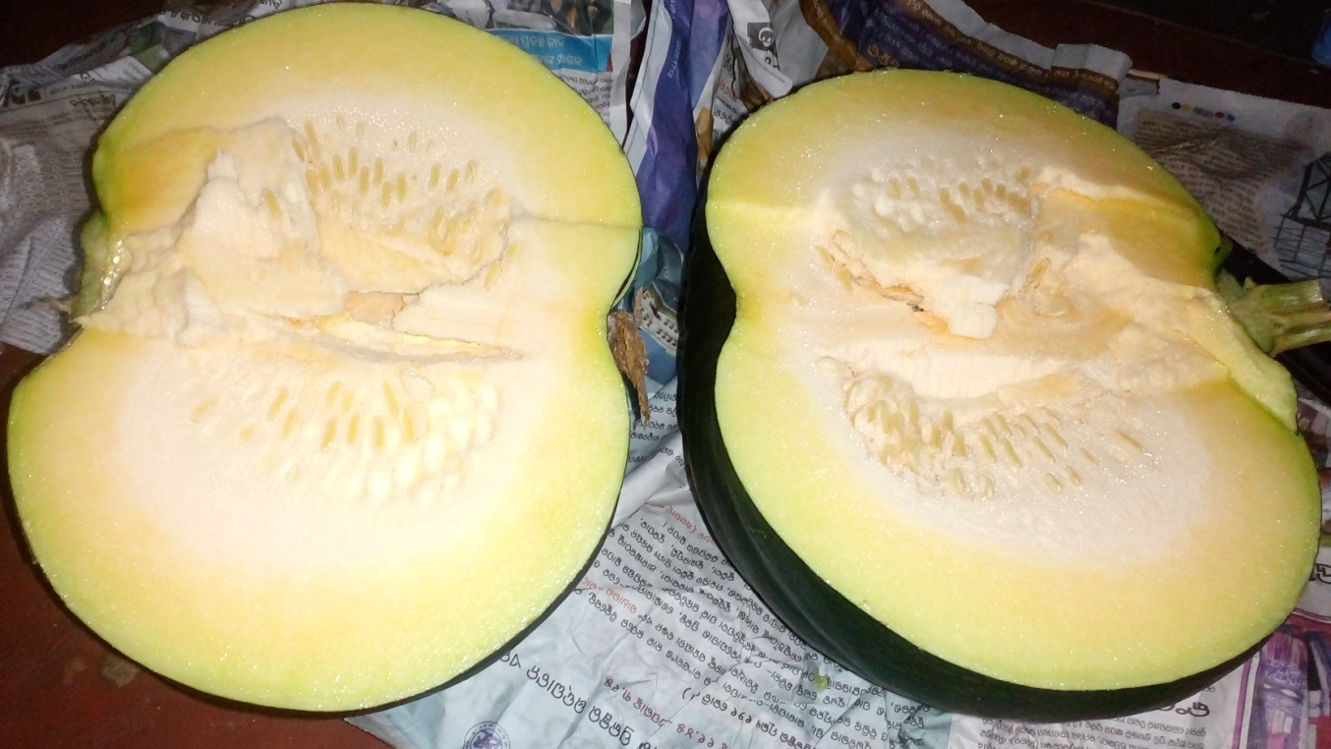

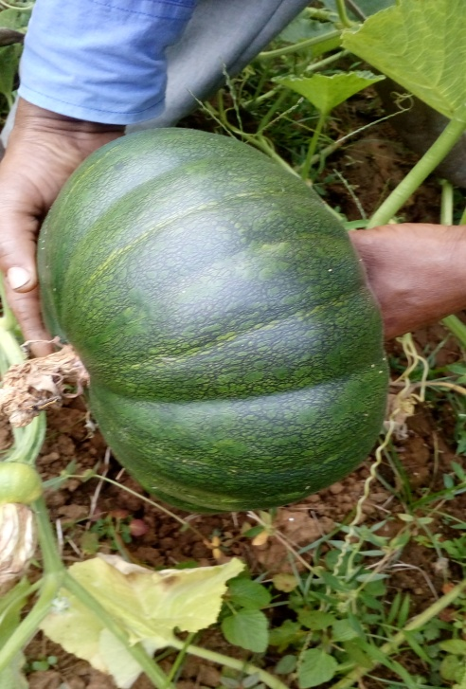 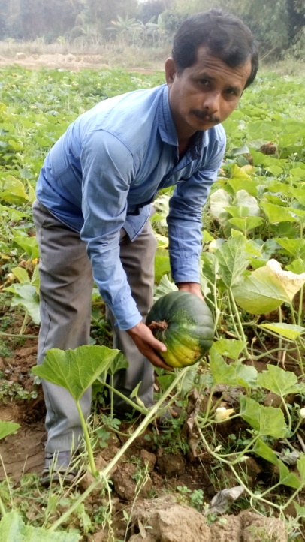

VNR 1-14 E.W. ARJUN

Remark:-

-This fruit has good market acceptance due to deep green in colour and good ridges. Sweet and colourful yellowish pulp.

- It can beat the competitors like Arjun(EW), Bhima(Sakata),Pratistha(Rasi)

- If commercially lunch I will able to sale minimum 30 Kg of this product in my territory .

BY…..

Prabhat Kumar Kundu

Sr. TSE, Bhadrak,Odisha

Emp Code – 0548